JavaScript library to build dynamic and interactive user interface.

React Native, a framework based on React, is specifically designed for mobile app development, while React Desktop allows you to create desktop applications using web technologies.

Developed by Facebook in 2011.

Used for frontend.

Used to create single page application (SPA).

Facebook, Netflix, Uber Eats.

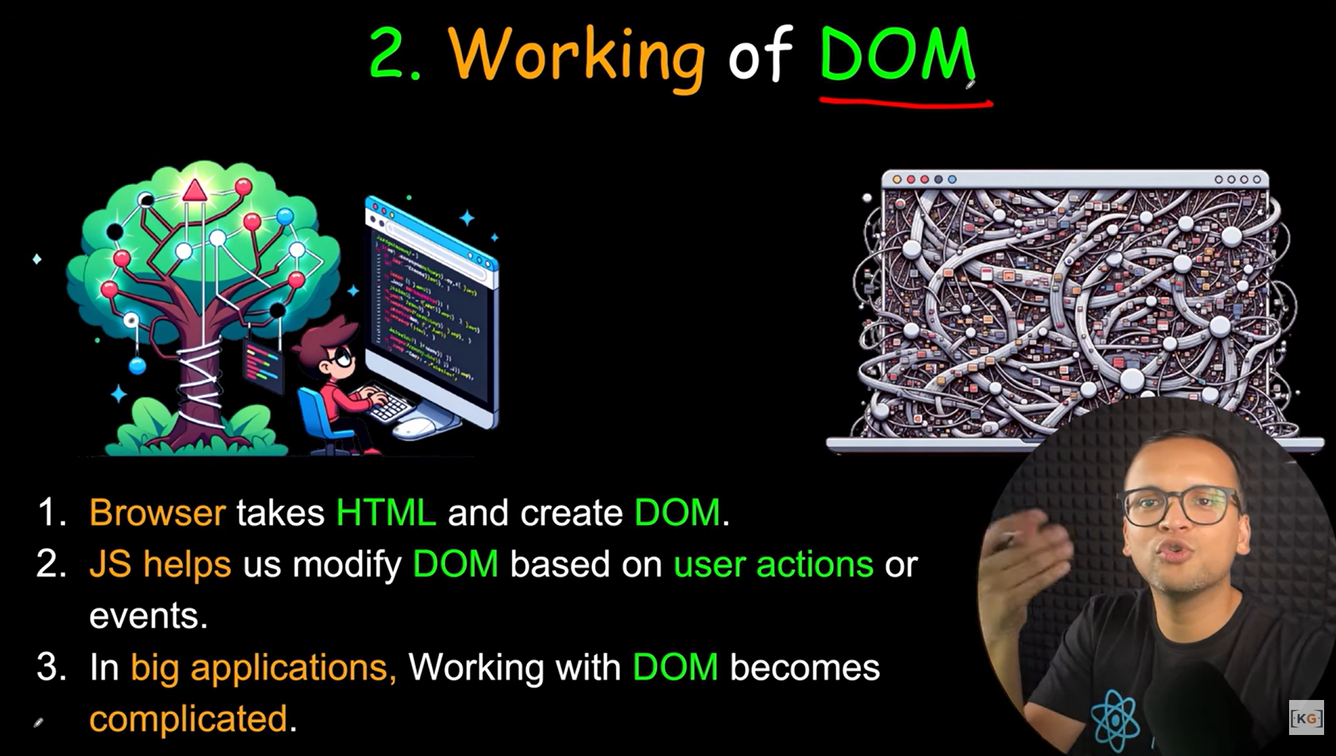

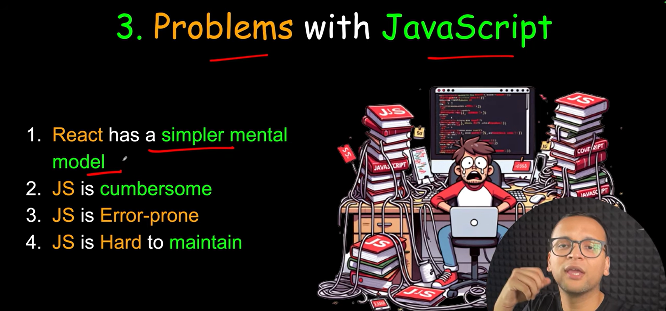

Working with react

No need to worry about querying and updating DOM.

React creates a web page with small and reusable component.

React will take care of creating and updating DOM element.

It saves a lot of time.

JS vs React

JS is imperative.

React is declarative.

